**Title of the Project**

***Suspicious Human Activity Recognition in Railway Stations***

**Description of the Project**

In today’s world, security has been a major concern for whether it is a bank, airport, railway station or a grocery shop or an individual, everyone wants themselves or their things to be safe from getting their valuable items harmed. Detecting such activities through a system is a challenging task, as most of them remains to be unambiguous, and people may misinterpret into other things.

Our project is to identify various suspicious activities that happen in a railway station. Activities like pickpocketing, theft, fights, crossing of railway track are most common, specially in India, where some individuals take advantage of the huge crowd to execute their vicious plans. Even if there was a system that can track human activities, detecting them is a challenging task as most of them has a probability of ambiguity. For example, two people running in a railway station can be interpreted as a person running after a robber or both individuals are running to catch their train.

**Name, Roll Number, Section, E-Mail, and Phone Number of Team Members**

|  |  |  |  |  |
| --- | --- | --- | --- | --- |
| **Name** | **Roll Number** | **Section** | **E-Mail** | **Phone Number** |
| Ajinkya Bedekar | U101116FCS183 | C5 | Ajinkya.Bedekar@st.niituniversity.in | 7389664860 |
| Ankit Gupta | U101116FCS267 | C5 | Ankit.Gupta@st.niituniversity.in | 9660765363 |
| Deeptonabho Dutta | U101116FCS030 | C5 | Deeptonabho.Dutta@st.niituniversity.in | 9674525644 |
| Dhruva Agarwal | U101116FCS177 | C5 | Dhruva.Agarwal@st.niituniversity.in | 7339764074 |

**Project Plan and Design**

1. Human Body Recognition
2. Basic Human Activity Tracking
3. Defining Unambiguous Suspicious Activities in Railway Stations
4. Training The Model

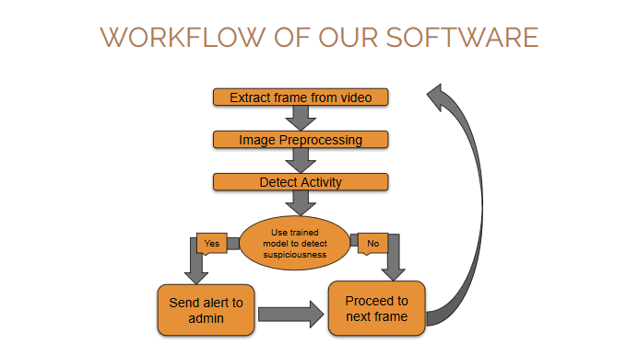

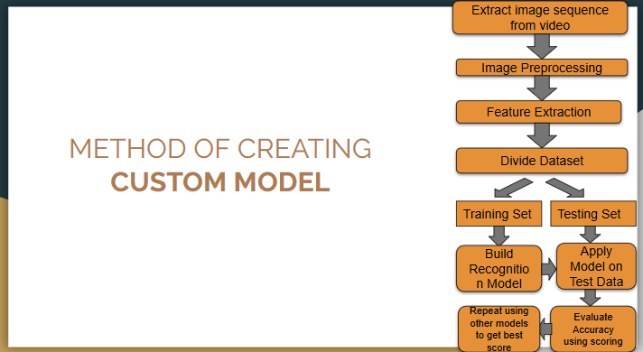

Our group has proposed a model that can overcome the given problem in a more efficient way. We executed it in the following way:

1. Accounting only those activities that highly remain unambiguous such as fights.
2. Making a dataset of suitable images that contain the specified activity. We can do this by either taking a video where such activity is occurring and converting it into frames.
3. Annotating the images using LabelImg software and bounding the relevant parts of the image that shows the execution of the activity.
4. Choosing a training model that works the most efficient way in a particular system.
5. Dividing the dataset into 90:10 ratio which accounts 90% for training and 10% for testing.
6. Feeding the annotated XML file and the images into that model for training.
7. Stop the training process when the total loss reduces to less than 1% in tensorboard graph.
8. System is built.

**Roles and Responsibilities**

|  |  |
| --- | --- |
| **Name** | **Module** |
| Ajinkya Bedekar | Human Body Movement Recognition |
| Ankit Gupta | Basic Human Activities Tracking |
| Deeptonabho Dutta | Defining Unambiguous Suspicious Activities In Railway Stations |
| Dhruva Agarwal | Training and Testing of the Custom Recognition Model |

**Snapshots of Project Execution**

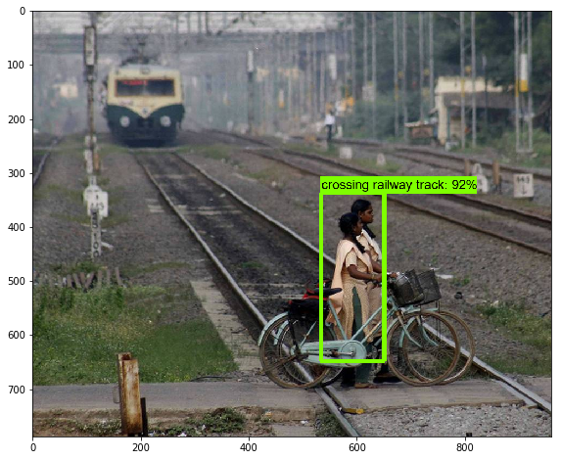

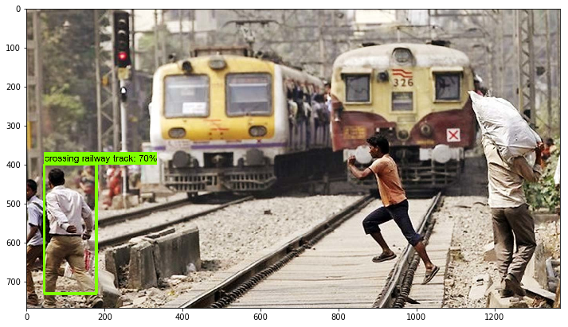

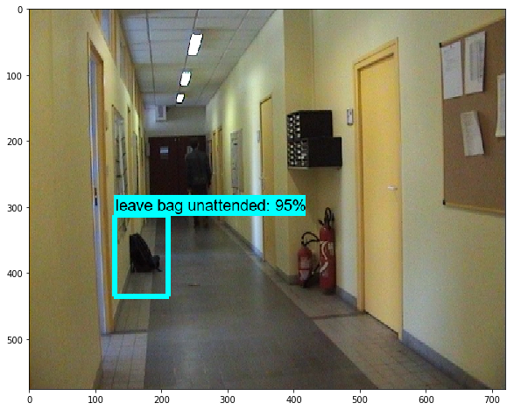

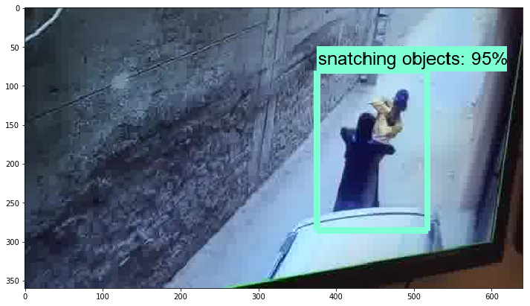

**Snapshots of Software Development Tools**

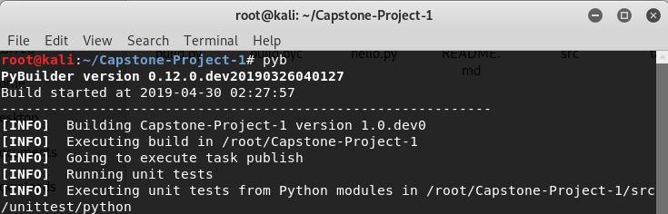

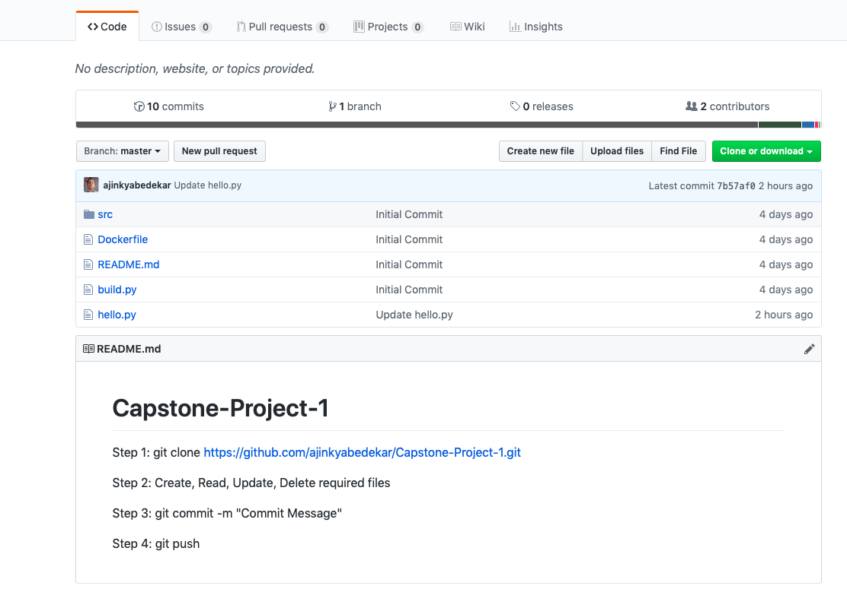

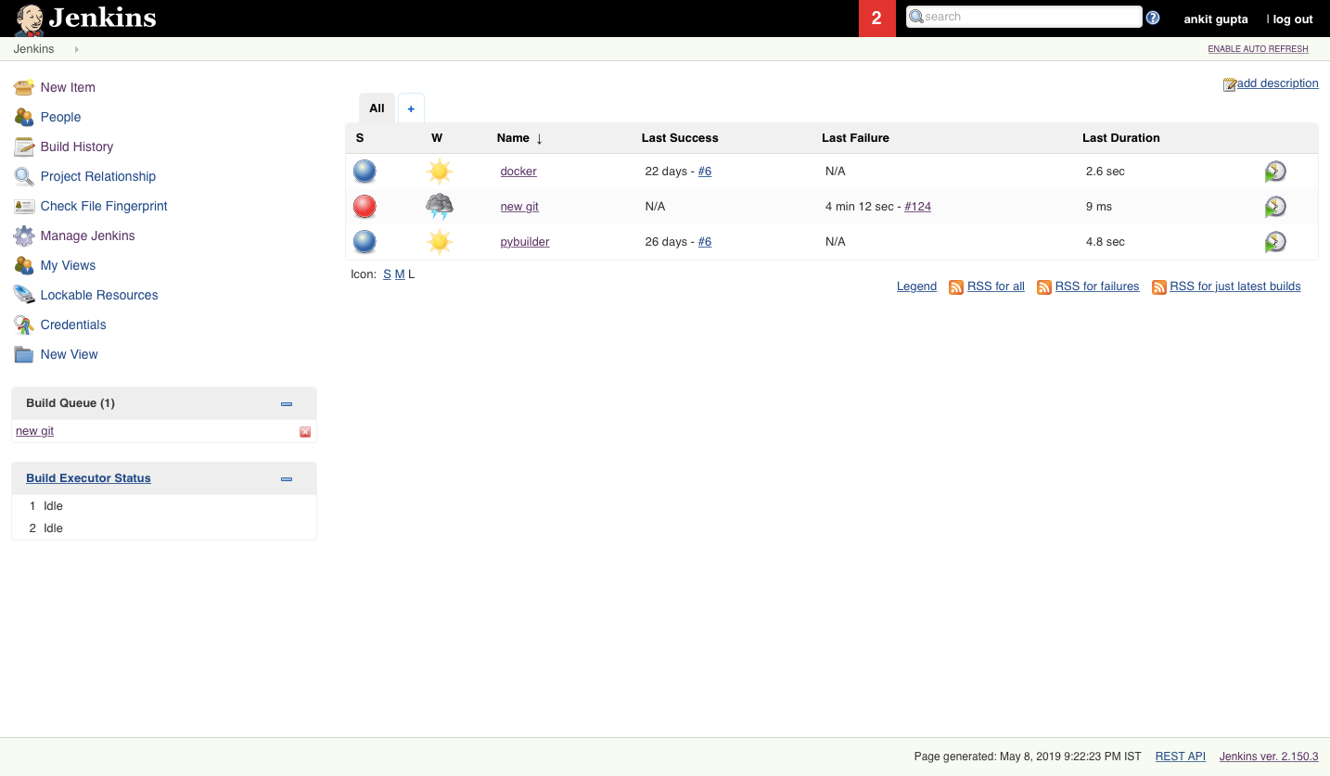

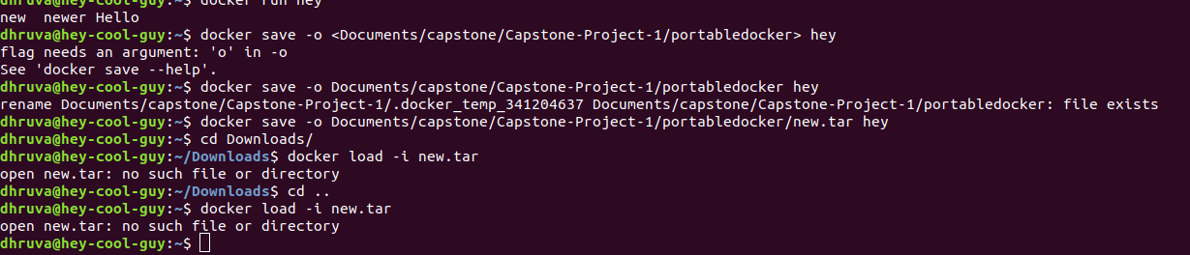

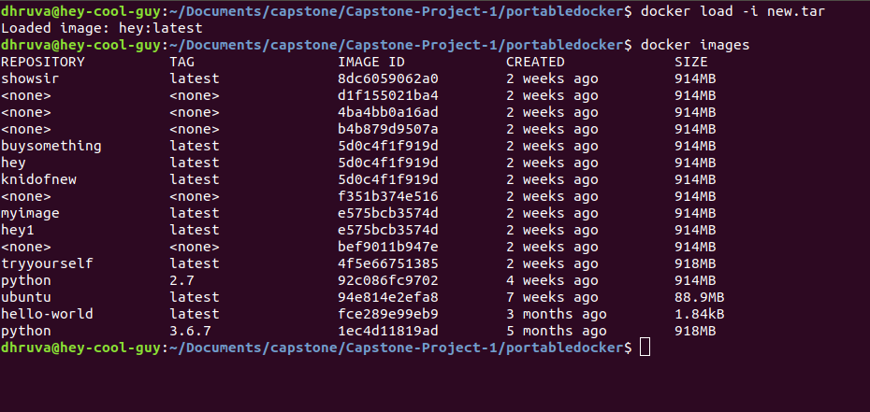

**Learning in the Project (including Tools and Technologies)**

* Learning in the Project
  + Continuous Integration and Continuous Deployment
  + Usage of Central Repositories
  + Build Tool deployment
  + Rigorous Unit Testing
  + Practical Knowledge in Computer Vision and machine learning domains
* Tools
  + PyBuilder
  + GitHub
  + Jenkins
  + Docker
  + PyTest
* Technologies:
  + OpenCV
  + Tensorflow
  + YOLOv3
  + Customization of Model
  + LabelImg

**Challenges During the Project**

* Building well labelled Dataset from scratch
* Training Custom Model

**Can your project be extended to Capstone 2? If yes, then mention what features can be added.**

Most of the work has already been implemented in our project in Capstone 1 only and we don’t think the leftover work would need one more semester for finishing. So, our team doesn’t think our project can be extended to Capstone 2.